(Approx. 942 words)

Video Conferencing for Clubs
Author: Dick Maybach, Member, Brookdale Computer User Group, NJ
www.bcug.com
n2nd (at) att.net

Many clubs have periodic general meetings, often with refreshments, speakers, and perhaps demonstrations or hands-on activities. The social interactions here, including the welcoming of prospective members, are vital for the organization’s health. Equally important are the committee meetings that support the organization. Here, much smaller groups, whose members know each other well, plan the club’s activities, and it may be more efficient to conduct some of these as video conferences, which would eliminate the associated travel. There is a major caveat: teleconferencing is ineffective if there are tensions within the group. Meet in-person to discuss a controversial issue.

There are two popular free services suitable for meetings of small groups: Facebook Messenger (http://www.facebook.com/messenger/) and Skype (http://www.skype.com/en/). Both require that participants register for the respective service, and all can be accessed from Linux, Windows, and Mac computers as well as Android and iOS devices. (These free services are provided by for-profit companies, and the usual caveat applies; they can be changed or discontinued any time their owners determine they aren’t sufficiently contributing to the bottom line.) If your club outgrows the scope of the free services, most vendors offer for-fee variants with more capabilities. You might also consider inexpensive paid services, such as EZTalks (http://www.eztalks.com/video-conference/) and Zoom (http://zoom.us/). Neither requires that users other than the moderator register for a service, but participants need to install the software. Both have trial versions that limit conferences to 40 minutes, which is certainly adequate for testing.

I’ll use Skype as an example, only because I already use it for one-on-one calls. Microsoft is refreshingly open about what it considers fair use (http://www.skype.com/en/legal/fair-usage/). In particular, “Group video calls are subject to a fair usage limit of 100 hours per month with no more than 10 hours per day and a limit of 4 hours per individual video call. Once these limits have been reached, the video will switch off and the call will convert to an audio call.” See the above URL for the other, quite reasonable, limits.

Skype’s interface varies with its version and your hardware and software; as a result, what you see may differ somewhat from the screenshots here. Figure 1 shows Skype’s opening screen, after the user has selected the Chats icon toward the upper left, and it shows one of Skype’s puzzles for new users. My name appears at the upper left, but you must contact me by my Skype name, which is “skype,alias” and appears towards the bottom right of the welcome screen in the sentence, “You are signed in as skype.alias.” (If you are not on the opening screen, find your Skype name by selecting the three dots to the right of your name at the top of the left panel, and then “Settings” followed by “Accounts & Profile.) Skype names are unique, but a search on a person’s given name will likely produce dozens of hits.

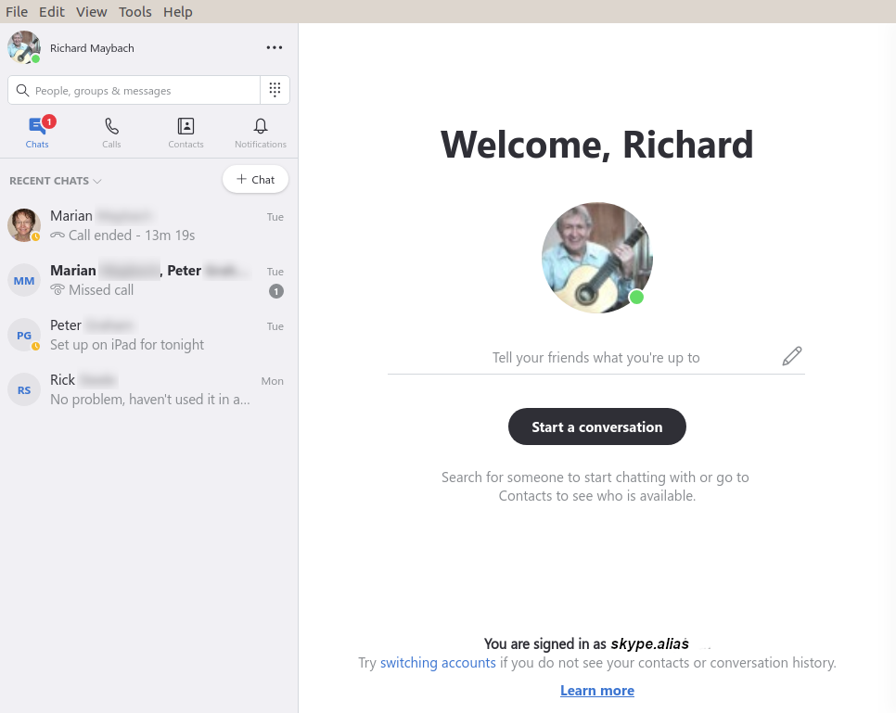
Figure 1. Skype Opening Screen.

To communicate with someone you must first add their name to your contact list. Select “Contacts” in the menu bar toward the upper left, then select the + button; enter their Skype name, and select the associated Add button. This will work only if they have enabled “Appear in search results.” (Go to Settings as above, then “Contacts” and “Privacy” to make this choice.) Many Skype names have the form “live:.cd.6f73e115260c0804”, and sometimes searches using the full name fail, but succeed if you delete the “live:.cd.” prefix.

Skype is different in that the moderator places a call to the participants, while other services require that the participants call into a conference. The set-up procedure varies with the version, and in Linux, it’s done by setting up a group chat. Select “Chats” in the menu bar toward the upper left and the “+ Chat” button, and finally “New Group Chat.” The result is in Figure 2. Select either the round button at top right, or “Select More People” toward the bottom, and add participants from your contact list. Selecting the camera icon at the upper right will start a video conference, and selecting the handset icon a voice conference. As the call begins, you will have an opportunity to ring the participants to alert them, which is probably a good idea.

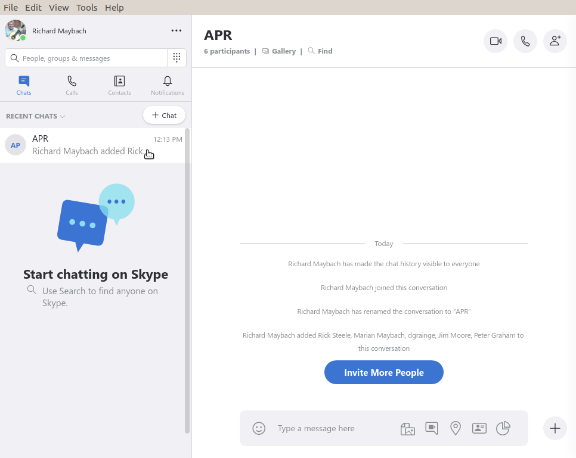
Figure 2. Define a Group Chat.

Although Skype conferences can be as large as 50, at most 10 of these can be transmitting video. This isn’t as restrictive as it may sound, as the audio participants still see the video. The screen is tiled, with a pane dedicated to each active video participant. As a result, each added participant reduces the size of all the others. Participants can disable their microphones to reduce the background noise and can also disable their cameras, using icons toward the bottoms of their screens, but these appear only when the cursor is active and on the Skype window. When disabled, a diagonal line appears on the associated icon. There is also a red handset icon here to terminate the call.

Skype’s interface varies with its version and your hardware and software, which may make it difficult to introduce to your organization. Expect your first conference to be awkward; even those accustomed to one-on-one video calls may find it confusing. You will most likely want to hold practice sessions, but the effort is worthwhile as there is much to gain. Replacing a face-to-face meeting with a video conference means a 20-minute meeting lasts just 20 minutes, instead of 30 to drive there, 20 to meet, and 30 to drive home, perhaps in ugly weather or traffic.

